Dear Elders & Sisters,

I believe in miracles. I have seen the Lord’s hand many times over in my life. In miraculous ways, I have seen the sick healed under the powers of the priesthood. I have seen the hand of the Lord revealed to provide safety and security. I have seen the powers of the priesthood bring the blessings of the atoning sacrifice to save individuals and families. I have witnessed the Lord bring about dramatic events to honor His promises and to bring people to the gospel truth. I believe in miracles.
As each of us, privately and personally, contemplate this time of personal missionary service, we often ask ourselves soul searching questions: Can I really be away from my family, friends and my life at home for this extended period of time? Can I truly live like a missionary and reach the high standards my mission president and the Brethren have of me? Can I be a person who can influence someone’s life, such that they join the Church and adopt the culture of the gospel? Can I find people and create a consistent set of investigators? Can I make this area productive so that people are being baptized? Can I attain the standards of excellence? Can I make a positive contribution to the mission goal of baptizing a virtual district?
Many more questions undoubtedly come to mind and some may challenge you to the point of feeling as if you have to escape, abandon the goal or standard, rationalize your weaknesses and justify a lesser standard or expectation due to the realities of doing this work in Africa, etc.
However, in the face of these questions and doubts, each of you has also had moments when you have felt the divine influence of the Spirit inspire you and confirm to you that your calling is of God and this is His work. Each of you has a portion of your thoughts where you know you are a daughter or a son of God and have divine potential and have a divine relationship with Heavenly Father. You know you have within you the ability to accomplish great things and you too believe that God, Our Heavenly Father, His Son Jesus Christ and our beloved companion the Holy Spirit want to bless us and want us to grow and become like them.
You too believe in and have witnessed miracles. Never, more than now, has there been a time for these miracles to be present in our lives. You have a sacred calling and represent the Lord, His Church, His prophets and they will perform miracles on your behalf. Dare to believe this and pray for and seek the blessing of these Divine Beings as you give yourself to this mission’s work. You will not be left alone. If you will knock, it shall be opened unto you.
Wishing you God’s greatest blessings.
With my deepest affection,
- President Erickson –
********************************************
Sister and Elders,
Did you know that this year marks the 20th anniversary of the document, THE FAMILY: A PROCLAMATION TO THE WORLD? This precious document revealed to us through living prophets, seers and revelators confirms for us the sacred nature of marriage between a man and a woman, and the divine role the family plays in our Heavenly Father’s plan.
Elder Bednar of the Quorum of the Twelve Apostles and his wife Sister Susan Bednar spoke at a special devotional meeting focused on marriage last week in Sydney, Australia.
Elder Bednar told those in attendance that “the best question to ask in a relationship is, ‘Lord, is it I?’ — meaning ‘Am I the one who needs to change?'"
As young missionaries, you are not married yet…but you are in a relationship with your companion! What a perfect question to ask yourself as you have companionship inventory or in your personal prayers. Having the humility to ask that question sincerely in any relationship where you may have differences or challenges shows your good character and your willingness to change.
Alma speaks of the mighty change of heart. This change of heart applies to so many areas of our lives. My hope for all of us is that we embrace this opportunity to make changes. Have faith that the Lord can make more of you than you will ever be able to make of yourself! Trust Him and see for yourself the miracle He will make you into!
Much love,
Sister Erickson
********************************************
Unlucky Day - Down 13
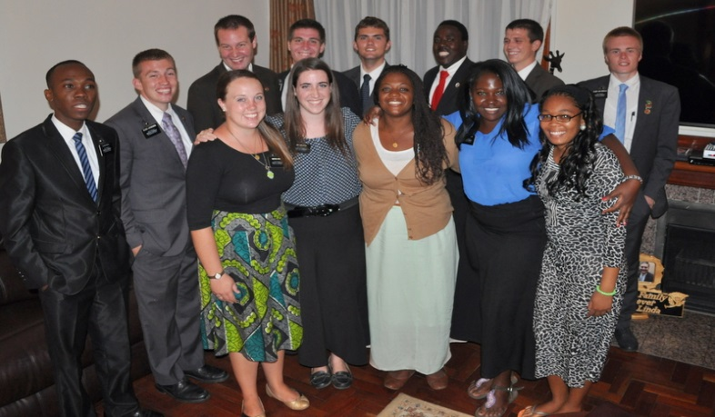
HAPPY BIRTHDAY!!! 1 – Elder Doig Elder Shabalala
4 - Elder Mohlakoana
Sister Erickson
10 - Sister Griffus
12 – Elder Barret
14 – Elder Chiliza
22 – Elder Hiltbrand

Roll Out the Welcome Wagon
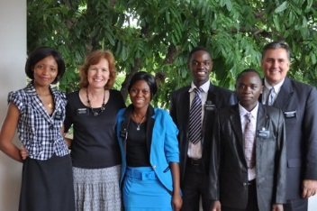
*************************************************
A BIG Welcome to these new missionaries
Sister Moyo (Zimbabwe), Sister Motsi (Zimbabwe), Elder Ssengooba (Uganda), and Elder Maele (Kenya).
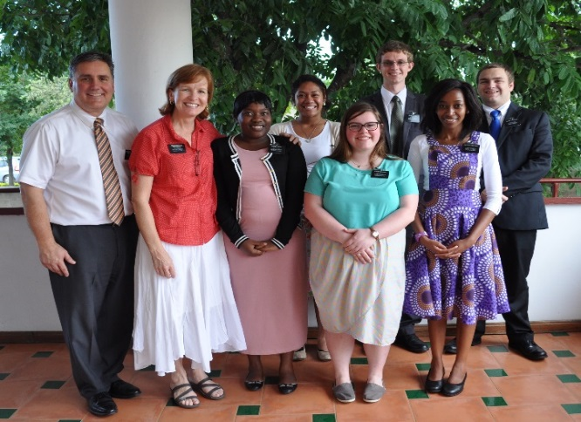

Sister Nkosi (South Africa), Sister Tuai (USA), Sister Zohner (USA), Elder Slade (Germany), Sister Kgwetiane (South Africa), and Elder Knobloch (USA).

We say our farewells to these GREAT missionaries - Elders Moya, Jorgensen, Barnard, Johnson, Hunter, Chathyoka, Blanchard, Van Arsdale - Sisters Jones, Lyon, Scott, Ruth, Nxele. They will be missed and their contributions to the mission and church will be remembered.
*********************************************
Recipe DuJour

From Sister Fisk

******************************************************
*****************************************************
Just a Thought…

In lieu of this being a month of green and pinches and four leaf clovers I thought we may think of something else green. That being, the green eyed monster of jealously. As we have been shifting gears and seeing many changes in ourselves, as well as the mission, we at times see the success of others and not the expected fruits of our own efforts. Elder Holland has warned us that "envy is a mistake that just keeps on giving. Obviously we suffer a little when some misfortune‍ befalls us,‍ but envy requires us to suffer all good fortune‍ that befalls everyone‍ we know! What a bright prospect that is—downing another quart of pickle juice every time anyone around you has a happy moment! To say nothing of the chagrin in the end, when we find that God really is both just and merciful, giving to all who stand with Him “all that he hath,”‍ as the scripture says. So lesson number one from the Lord’s vineyard: coveting, pouting, or tearing others down does not‍ elevate your‍ standing, nor does demeaning someone else improve your self-image. So be kind, and be grateful that God is kind. It is a happy way to live." Let us be happy for one another and optimistic in the work. There will always be a pot of gold at the end of the rainbow when we can delight in the happiness and success of others.
****************************************************
Are you Keeping a Balanced Lifestyle….?

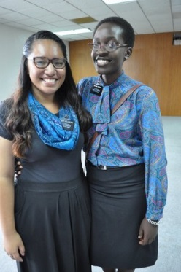

It’s fun to have fun but you got to know how. -Dr. Seuss

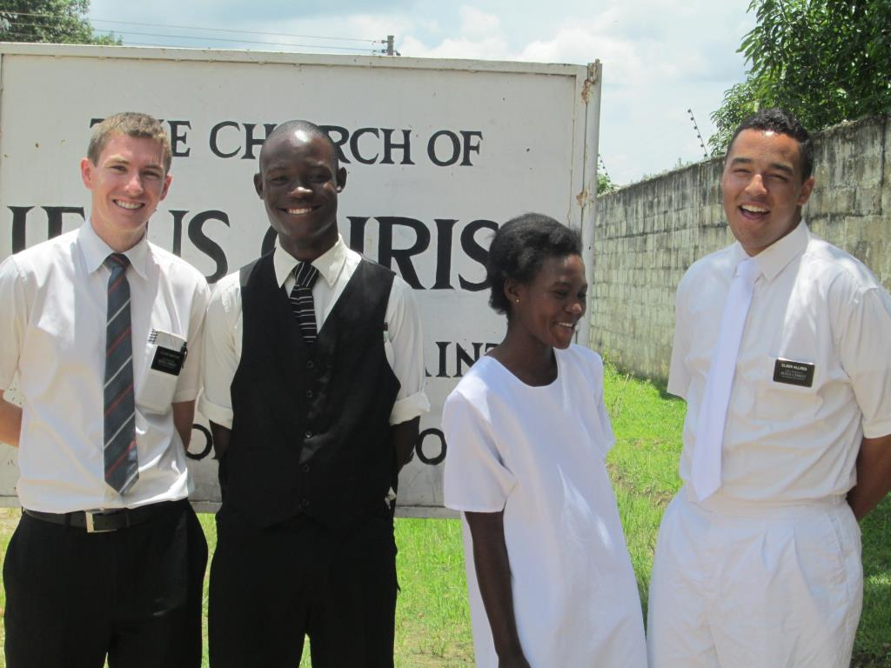

Elder Barton & Elder Allred taught and baptized Jessica Bowa from the Matero Branch. Here they are with Davis Chifunda.
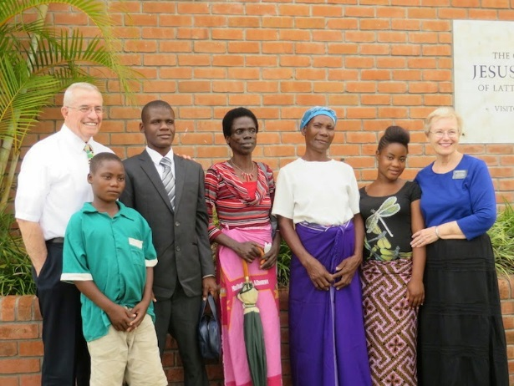
We’re sending em out .
Felix Paul has been called to serve. He and his family with the Merrills.

We are missionaries who focus on FAMILIES

GREAT JOB ELDERS AND SISTERS!!!!
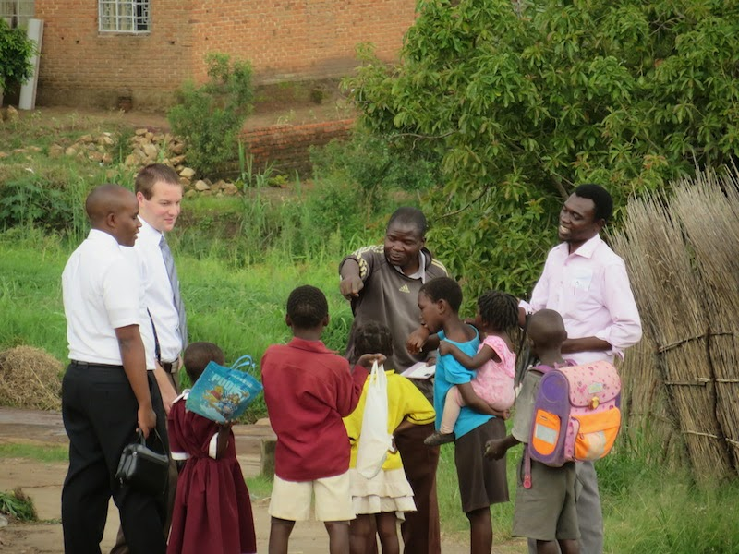

If there is anything you would like to see in the monthly newsletter email us in the office at 1461788@ldschurch.org

